

**Submitted To:**

Mrs. Syeda Ramish Fatima

**Submitted By:**

Muhammad Ashar Khan (CS-24035)

Usman Rasheed Siddiqui (CS-24038)

**Submitted On:**

21th February 2025

**Object Oriented Programming**

(CS-116)

Graded Assignment 1: Class Diagrams

COMPUTER AND INFORMATION SYSTEM ENGINEERING

NED UNIVERSITY OF ENGINEERING AND TECHNOLOGY

**Colors for Association Types in Class Diagram:**

1. #FCEF61 (For Main Class)
2. ⁠#A3E0FF (For Aggregation)
3. ⁠#A3FFA3 (For Composition)
4. ⁠#C6C6C6 (For Generalization)
5. ⁠#FF8282 (For Association)
6. #79FFE8 (For Multiple Associations on a single class)

**Class Diagram Representation of Problem Scenarios:**

Question 1:

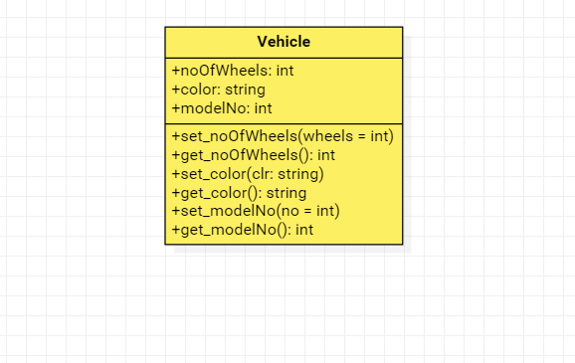

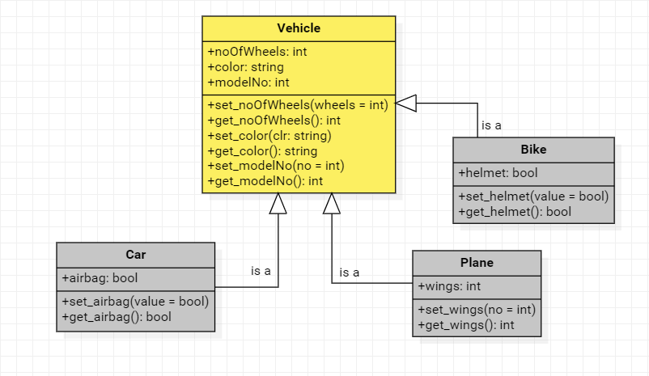Question 2:

Question 3:

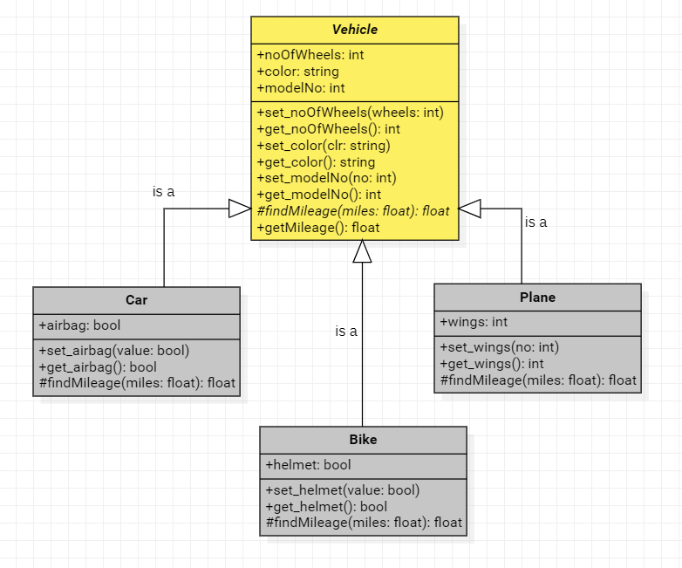

Question 4:

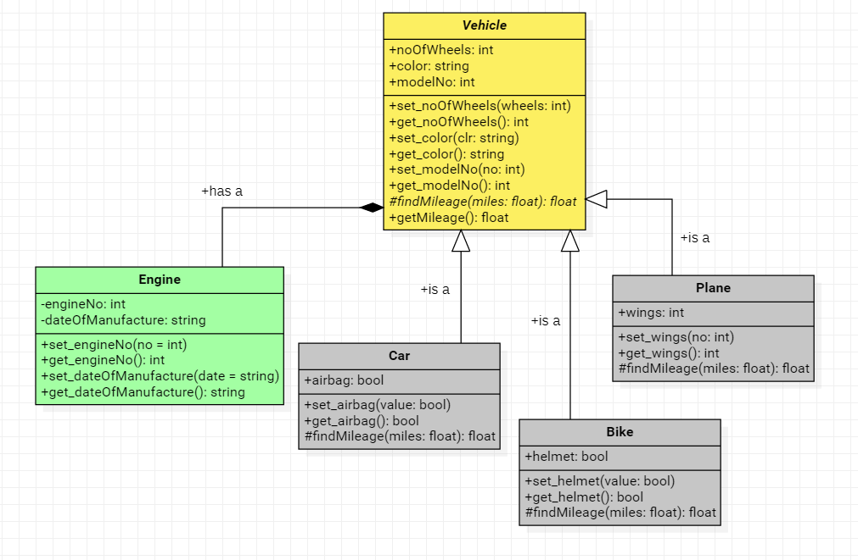

Question 5:

Part (a):

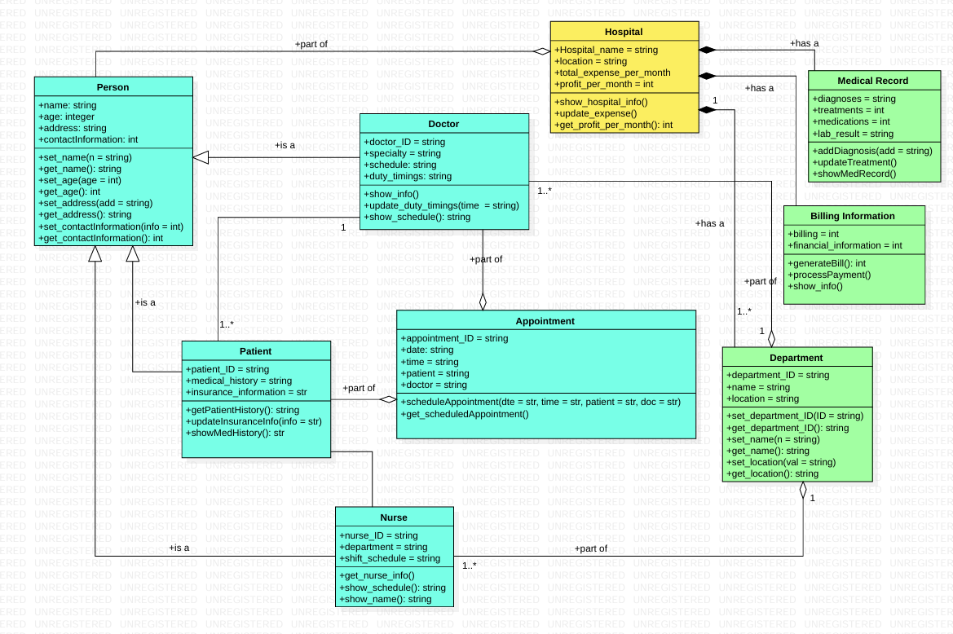

Part (b):

